Team Effort

* Wi-Fi is connected to the internet

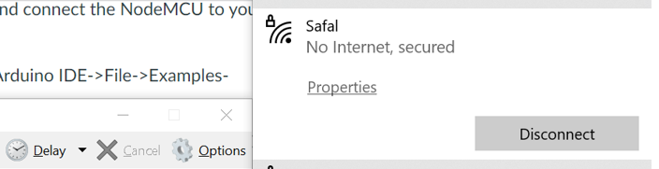

* Band 115200 serial port

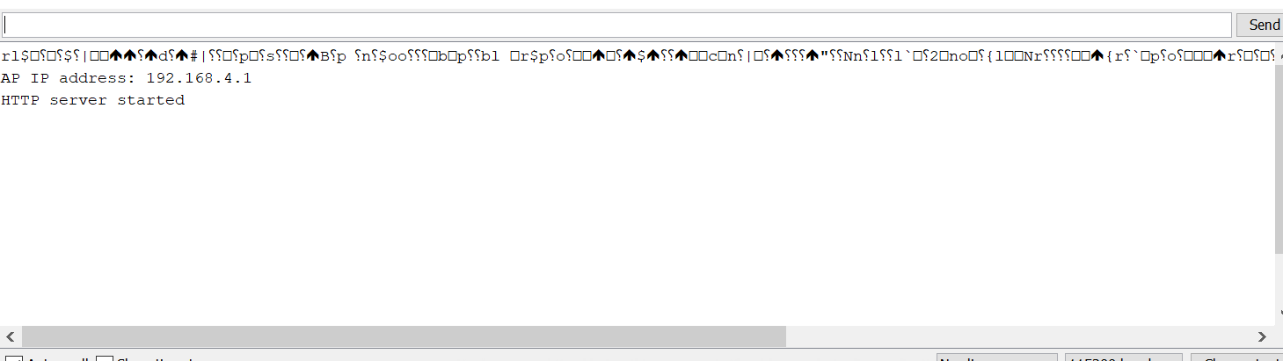

* Accessing the IP

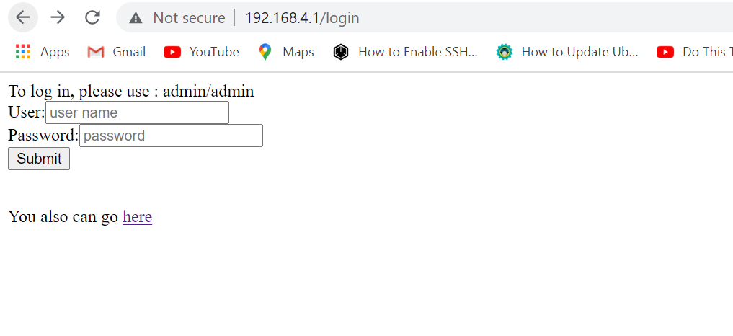

* Connection

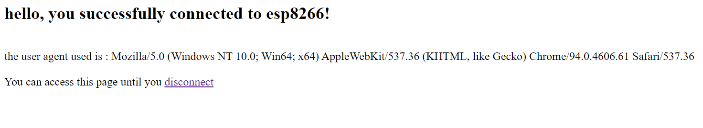

Cracking the Wi-Fi Password

1. If you are connected, you can always find the IP of that AP

* Go to CMD and then type ipconfig

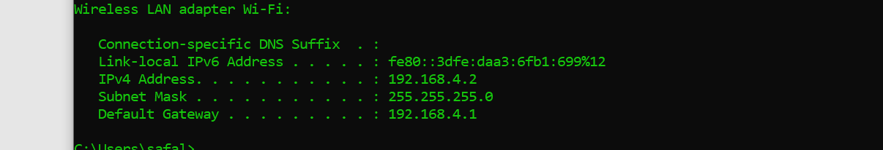

But you need to have the access to the gateway, in our example we can use admin as password and username. If you can login then you can see the password

1. You can go to network and internet settings in the PC

* Network and Sharing center

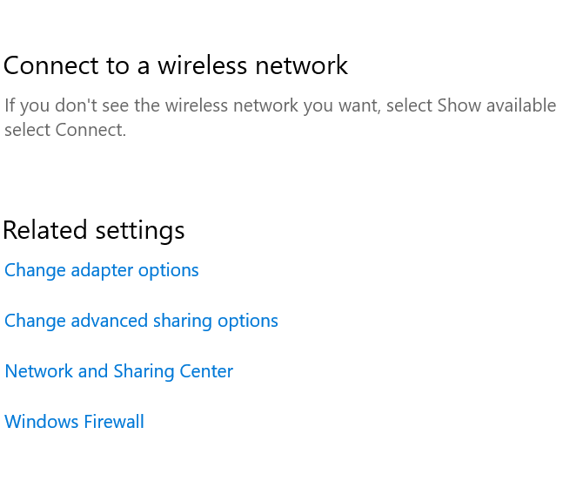

* Click on connections

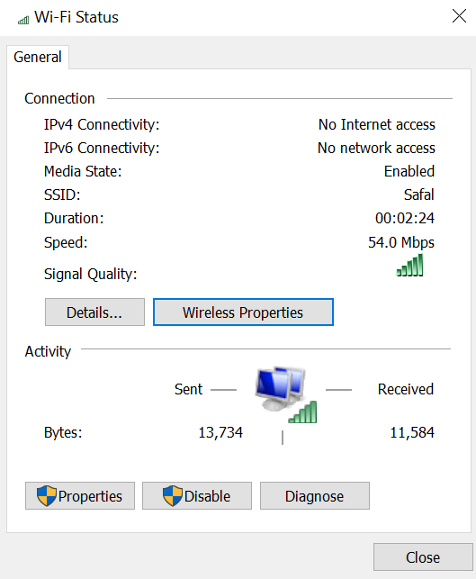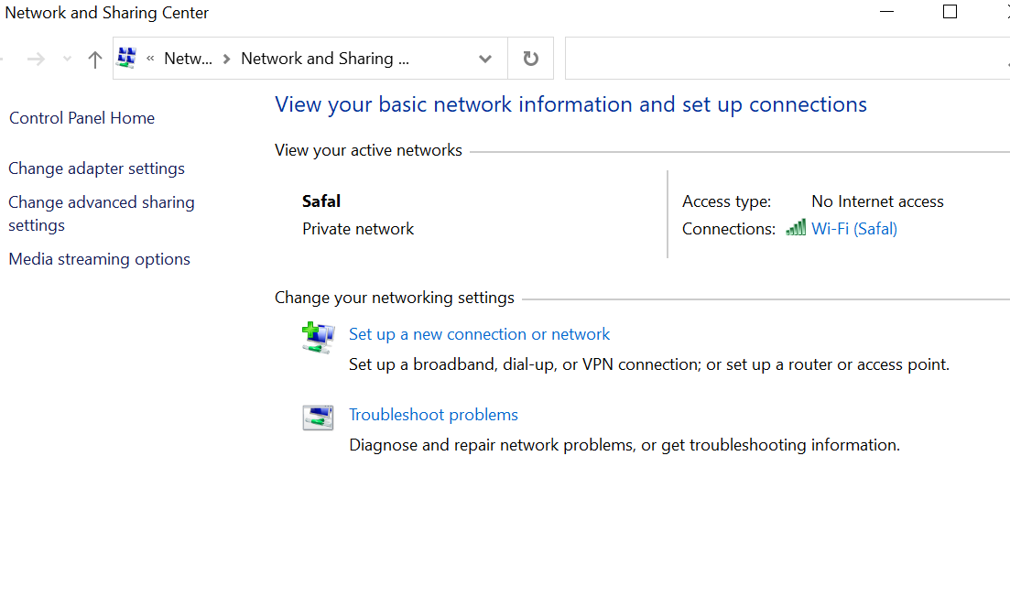

* Click on Wireless properties

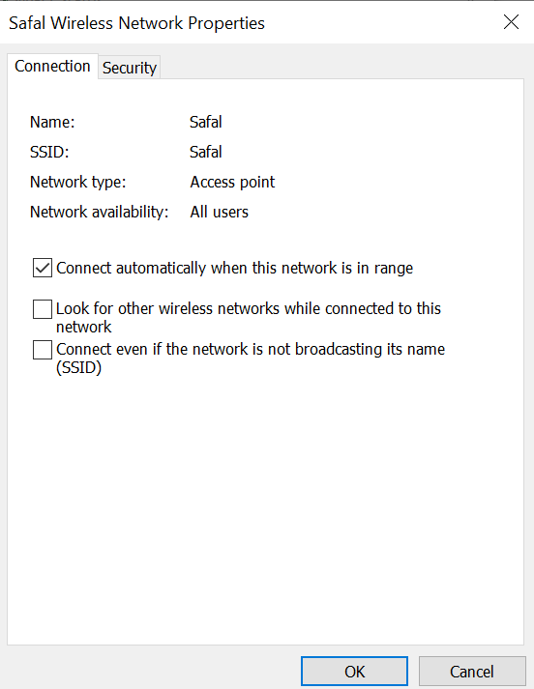

* Click on Security and show password

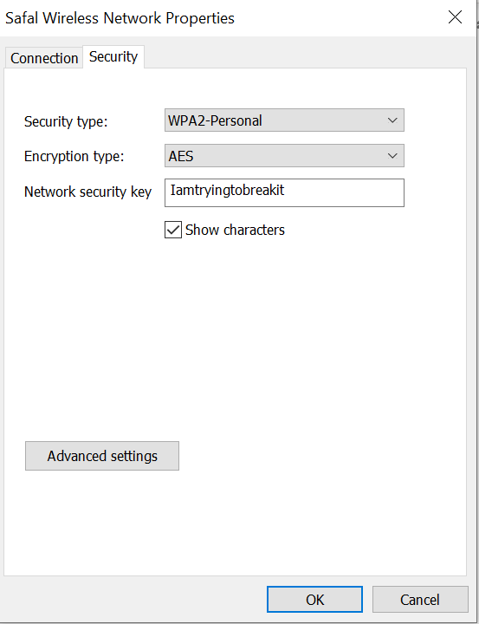

You can see the password of connected AP

1. Using build in functions from mobile

* 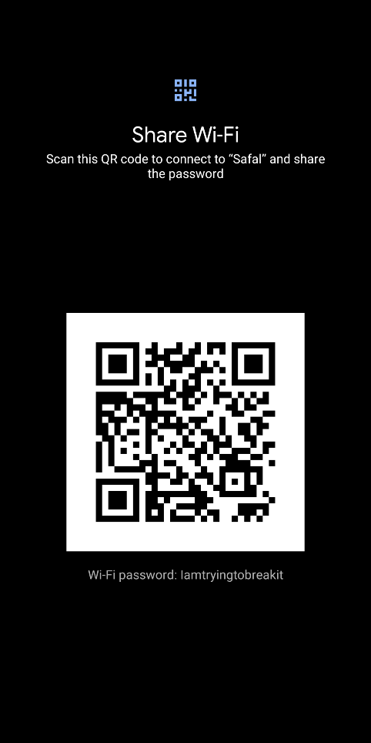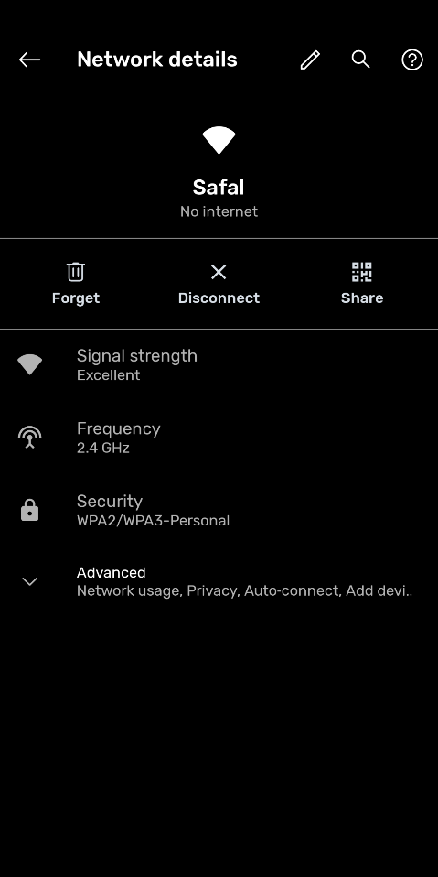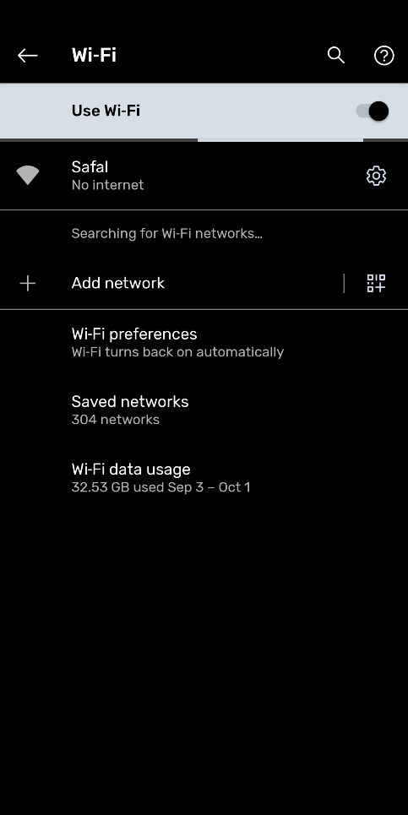Open Wi-Fi settings and click on share

